# Over the Counter (OTC) Health Solutions

General Information

Benefits of OTC Health Solutions Program

Ordering OTC Products

Tracking OTC Health Solutions Orders

Related Documents

**Description:** This document provides information for the CCR to help answer questions the beneficiary may have on OTC Health Solutions.

|  |
| --- |
| General Information |

OTC Health Solutions is a CVS Pharmacy program that provides over the counter (OTC) benefit administration. There are over 1,000 products and a plan can choose to offer the full list of products or a subset of them.

**Note:** Do **NOT** proactively offer this program to beneficiaries or advise any beneficiary they are eligible for this benefit. Only certain beneficiaries of the plans listed below are eligible for an OTC benefit.

 Warm transfer the beneficiary to OTC Health Solutions at **1-888-628-2770** to place an order, have questions regarding an existing order or about the OTC benefit.

* Hours of Operation
  + Monday to Friday from 9 AM to 8 PM (local time).
  + New Year’s Day 1/1/25 – 9 AM to 5:30 PM ET
  + Martin Luther King Jr Day 1/20/25 – Closed
  + Memorial Day 5/26/25 – Closed
  + Independence Day 7/4/25– Closed
  + Labor Day 9/1/25 – Closed
  + Thanksgiving Eve 11/26/25 – 9 AM to 5:30 PM ET
  + Thanksgiving Day 11/27/25 – Closed
  + Christmas Day 12/25/25 – Closed
* Beneficiary can also place order 24/7 using the automated IVR system or online by visiting the plan webpage.
* To speak with a live agent advise the beneficiary to call back during business hours

OTC Health Solutions:

* Is separate from the pharmacy benefit
* Requires **NO** prescription
* Has nationwide mail service capability and the beneficiary does not pay shipping cost

OTC Health Solutions has an in-house fulfillment center and customer service call center with English and Spanish speaking agents (translation line also available). If a beneficiary would like to place an order or has questions about this benefit or an existing order, warm transfer the call to OTC Health Solutions at **1-888-628-2770**. The IVR is available 24 hours a day / 7 days a week.

**Note:**  Beneficiariesdo not require a separate card for this benefit. OTC Health Solutions use the beneficiary’s health plan ID.

Top of the Document

|  |
| --- |
| Benefits of OTC Health Solutions Program |

Benefits of using this program include:

* **OTC Health Solutions – Traditional Program:**
  + Beneficiaries receive an allowance from their health plan to spend on eligible OTC products.
    - Beneficiary cannot exceed the benefit when placing orders through home delivery (call center, online, or app).
    - Beneficiary can only exceed benefit in-store and pay difference out of pocket.

Top of the Document

|  |
| --- |
| Ordering OTC Products |

Beneficiaries can order these OTC products:

* Online by going to [www.cvs.com/benefits](http://www.cvs.com/benefits) and creating an account
* By phone through the OTC Health Solutions call center
  + IVR option also available 24/7
* By downloading the OTCHS mobile app.
* At any CVS Pharmacy locations (excluding Target or Schnucks stores).
  + Not all health plans offer a retail option for this benefit- some only allow online or by phone orders.
  + Beneficiaries can locate OTC enabled stores by visiting the OTCHS web page and utilizing the store locator feature on the upper right-hand corner of the landing page.

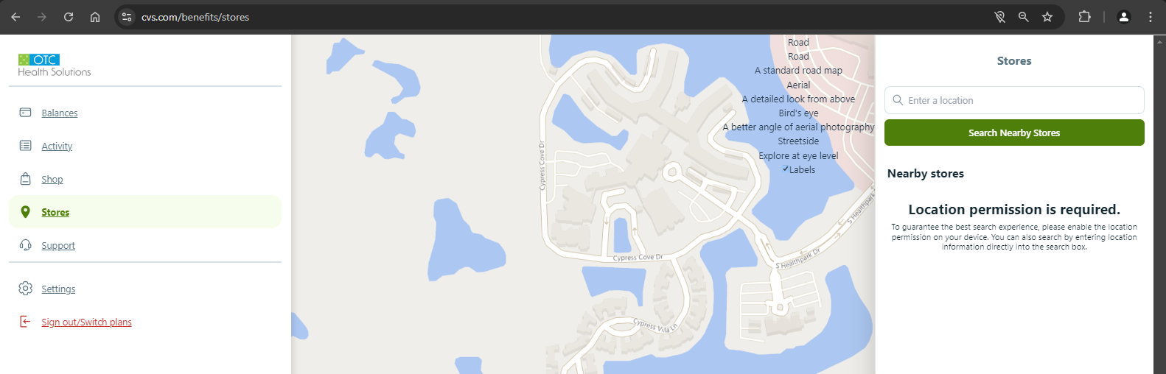

Top of the Document

|  |
| --- |
| **Benefits of CVS Flexcard Offering** |

Benefits of using this program include:

* **CVS Flexcard Offering:**
  + The Flexcard program allows beneficiaries to select from a variety of categories in-store.
    - Depending on the plan, a beneficiary can place one, two, or multiple orders per benefit period (monthly, quarterly, or annually benefit).
    - Depending on the plan, a beneficiary can place an unlimited number of orders in stores.
    - Beneficiaries can order up to 3 of each item per month or up to 9 of each item per quarter.
    - Blood pressure monitors, weight scale and Pulse oximeter are limited to 1 per year.
    - Certain items are limited to 1 per benefit period (month or quarter). This is indicated in the beneficiary’s catalog.
    - Most of the OTC products are CVS Health brand products (generic brand).
  + Several national brand items have been added for 2025.
  + No returns or exchanges are allowed for home delivery.

Top of the Document

|  |
| --- |
| Tracking OTC Health Solutions Orders |

A beneficiary can track orders online and using the IVR.

* Beneficiaries who register online will receive order tracking updates via email.
* Beneficiaries can opt in to receive order tracking updates via text messaging when they call the OTCHS call center.

Top of the Document

|  |
| --- |
| **List of Health Plans** |

Below is a list of health plans that OTC Health Solutions services, which use the [www.cvs.com/benefits](http://www.cvs.com/benefits) url:

|  |  |
| --- | --- |
| **Health Plans** | |
| UHC LTC & MEDICAID FL | AETNA MERITAIN VALUE |
| CENTENE MEDICAID | AETNA MEDICAL |
| MERCY AZ MEDICARE | SODA HEALTH (OTC HD) IMPERIAL |
| Aetna Medicare | SODA HEALTH (OTC HD) GHC |
| Aetna ISNP | WEX (ZING) |
| Allina Health | SIMPLY (Medicaid) |
| ABH FL MEDICAID | SIMPLY MEDICARE |
| ABH KS MEDICAID | CLEAR HEALTH ALLIANCE MEDICAID |
| ABH KY MEDICAID | FLORIDA COMMUNITY CARE MEDICAID |
| MOLINA HEALTHCARE (MEDICAID) | FLORIDA COMPLETE CARE (FC2) MEDICARE |
| ABH LA MEDICAID | MARTIN'S POINT MEDICARE |
| ABH MD MEDICAID + Grocery | MEDICA MN MEDICARE |
| ABH PA (CHIP) MEDICAID | MEDIGOLD MEDICARE |
| ABH TX MEDICAID + Grocery | BC/BS MN DUALS |
| ABH VA MEDICAID | BC/BS MN MEDICARE |
| AETNA ILLINICARE MEDICAID + Grocery | BLUE SHIELD OF CA MEDICARE/MEDSUPP |
| ABH MI MEDICAID + Grocery | INDIANA UNIVERSITY MEDICARE |
| ABH OH MEDICAID | Centene MMP |
| ABH OK MEDICAID | JOHN HOPKINS MEDICARE |
| AETNA COMMERCIAL | CARELONRX AMERIGROUP MEDICAID |
| AETNA CVS IFP | MyTruAdvantage MEDICARE |

Below is a list of health plans that are Traditional/Flex and use the [www.mybenefitscenter.com](http://www.mybenefitscenter.com) url:

|  |  |
| --- | --- |
| **Health Plans** | |
| Aetna DSNP | SHARP MEDICARE |
| InComm (OTC HD) | UAW BUDD COMMERCIAL |
| DEVOTED HEALTH MEDICARE | IMCARE MEDICARE + Grocery |
| FLORIDA COMPLETE CARE DSNP + GROCERY | UAW TRUST |
| BC/BS MN MEDICARE | SCAN HEALTH PLAN MEDICARE + Grocery |

Top of the Document

|  |
| --- |
| Related Documents |

**Parent SOP:** CALL-0048: [Medicare Part D Customer Care Call Center Requirements-CVS Caremark Part D Services, L.L.C.](https://policy.corp.cvscaremark.com/pnp/faces/SecureDocRenderer?documentId=CALL-0048&uid=pnpdev1)

**Abbreviations/Definitions:** Abbreviations / Definitions

Top of the Document

Not to Be Reproduced or Disclosed to Others without Prior Written Approval

**ELECTRONIC DATA = OFFICIAL VERSION / PAPER COPY = INFORMATIONAL ONLY**